FINAL EVALUATION REPORT
Project Name: “Towards social protection and inclusion of informal waste pickers and recyclers in Southern Cities”
Duration: 1/2011-12/2014
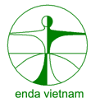
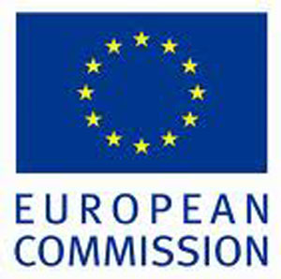

Reported by: Nguyen Thi Hoai Linh

Ho Chi Minh City, 10/2014
ABBREVIATIONS

FGD  PMB  MB | Focus Group Discussion  Project Management Board  Management Board
LISA | Labor-Invalid and Social Affairs
IWCs | Informal Waste Collectors
DONRE | Department of Natural Resources and Environment
PC | People’s Committee
- GENERAL INFORMATION:
With financial support from the European Union, Environment Et Developpement Du Tiers-Monde (Hereinafter referred to as Enda Vietnam) has implemented the project "Towards social inclusion and protection of informal waste collectors and recyclers in Ho Chi Minh city ". The overall objectives of the project are (i) To improve the working conditions of the IWPAR, reducing health risk factors (ii) To improve access to health insurance and services for IWPARs at local level (iii) To insert IWPAR organizations’ business activities in integrated waste management systems. The project has been implemented from 2011 to 2014 and needs to conduct evaluation of the overall impact of the project on informal waste collectors in Ho Chi Minh City and also gives the evaluation of the city’s solid waste management.

II. EVALUATION METHODS
This report has been included both quantitative and qualitative methods and conducted at 7 Districts including District 4,5,6,10,11, Binh Thanh District and Thu Duc. Evaluation methods used are literature review, in-depth interviews, focus group discussions (FGDs) and to visit the waste collection process of IWCs’ forces.
Quantitative data has been collected through a monitoring system to follow up the project implementation. Qualitative data were collected through interviews of representatives from most of the parties involved in the project, from informal waste collectors, Syndicates and Cooperatives’ Management Board to the local officials. There were 133 IWCs (48 females: 36% & 85 males: 64%) participated in qualitative interviews, 16 FGDs (54 females: 39% & 84 males: 61%) and experience exchanges with experts of Ho Chi Minh City Department of Natural Resources and Environment.
A variety of data collection tools have been developed based on the requirements of the evaluation and based on the research of project documentation (proposals, mid-term evaluation report ...). Those are:
- Questionnaire to direct interview IWCs and observation: this questionnaire is designed to understand consciousness and behavior of IWCs on occupational safety, first aid, diseases prevention related to waste collection, IWCs’ awareness on the access to social protection and inclusion in order to determine the appropriate in selection of beneficiaries as well as the support of the project.
- Questionnaire for IWC’s FGDs: This questionnaire is designed to understand the intervention process to project beneficiaries in order to evaluate the project impacts on improving living standards of IWCs as well as changing community behavior toward IWCs.
- Questionnaire to interview members of Syndicates/ Cooperatives Management Board. This questionnaire is designed to collect information on cooperatives/ syndicates’ activities, the benefits of these activities for IWCs, the project impacts on IWCs, the capacity building activities which they participated and the effect of these activities, the abilities to maintain after the project ends...
The above information has given a multidimensional point of view on the project in order to evaluate all achievements and lessons gained through project implementation.

- MAIN FINDINGS:
- Project Achievements:
The direct support for informal waste collectors: In the past four years, the project has supported 3,690 protective clothes for 1,631 IWCs (female: 719 & male: 912), 436 health insurance cards for 436 IWCs (female: 207 & male: 229), 1,096 accident insurance for 1,096 IWCs (female: 434 & male: 662), 1238 IWCs (female: 507 & male: 731) were annually checked up and 820 IWCs were injected tetanus (female: 312 & male 508)
NUMBER OF PROJECT BENEFICIARIES RECIEVING DIRECT SUPPORT FROM 2011 TO 2014
District | Gender | Annual check-up  until 2014 | Tetanus injected until 2014 | Health insurance until 2014 | Protective clothes until  2014 | Accident Insurance until 2014
Dist 4 | Male | 93 | 99 | 25 | 80 | 53
Dist 4 | Female | 55 | 53 | 31 | 49 | 40
Dist 4 | Total | 148 | 152 | 56 | 129 | 93
Dist 5 | Male | 120 | 55 | 34 | 102 | 73
Dist 5 | Female | 76 | 40 | 35 | 81 | 55
Dist 5 | Total | 196 | 95 | 69 | 183 | 128
Dist 6 | Male | 82 | 109 | 24 | 128 | 100
Dist 6 | Female | 77 | 80 | 23 | 88 | 76
Dist 6 | Total | 159 | 189 | 47 | 216 | 176
Dist 10 | Male | 61 | 37 | 30 | 100 | 47
Dist 10 | Female | 64 | 31 | 25 | 67 | 43
Dist 10 | Total | 125 | 68 | 55 | 167 | 90
Dist 11 -Cooperative | Male | 46 | 82 | 13 | 25 | 25
Dist 11 -Cooperative | Female | 25 | 45 | 11 | 20 | 20
Dist 11 -Cooperative | Total | 71 | 127 | 24 | 45 | 45
Binh Thanh  Dist | Male | 166 | 239 | 54 | 171 | 143
Binh Thanh  Dist | Female | 126 | 137 | 47 | 124 | 82
Binh Thanh  Dist | Total | 292 | 376 | 101 | 295 | 225
Thu Duc Dist-Cooperative | Male | 80 | 73 | 39 | 60 | 130
Thu Duc Dist-Cooperative | Female | 37 | 39 | 22 | 128 | 63
Thu Duc Dist-Cooperative | Total | 117 | 112 | 61 | 188 | 193
Thu Duc Dist-Syndicate | Male | 47 | 53 | 4 | 129 | 91
Thu Duc Dist-Syndicate | Female | 42 | 30 | 6 | 70 | 55
Thu Duc Dist-Syndicate | Total | 89 | 83 | 10 | 199 | 146
Dist 11-  BoNRE | Male | 0 | 0 | 0 | 77 | 0
Dist 11-  BoNRE | Female | 0 | 0 | 0 | 62 | 0
Dist 11-  BoNRE | Total | 0 | 0 | 0 | 139 | 0
Go Vap Dist | Male | 30 | 64 | 0 | 40 | 0
Go Vap Dist | Female | 27 | 46 | 0 | 30 | 0
Go Vap Dist | Total | 57 | 110 | 0 | 70 | 0
Total | Male | 725 | 811 | 223 | 912 | 662
Total | Female | 529 | 501 | 200 | 719 | 434
Total | Total | 1,254 | 1,312 | 423 | 1,631 | 1,096

Source: Enda
Capacity building for IWCs: Over the years, the project has organized training courses to build capacity for IWCs. Specifically, there were 795 IWCs participating in training courses occupational safety and first aid (female: 323 & male: 472); training on skills of group communication for 164 IWCs (female: 41 & male: 123); training on gender equality and prevention of domestic violence for 548 participants (female: 218 & male: 330); 77 team leaders and deputy team has been trained on occupational diseases related to waste collection. After training for team leader / deputy leaders, project encouraged them to start communication, share their knowledge to their group’s members.
NUMBERS OF PARTICIPANTS ON TRAINING COURSES OF CAPACITY BUIDING FROM 2011 TO 2014

District | Gender | Occupational safety and  first aid | Gender equality | Communication skill | Disease prevention | Project management | Environmental law | Labor Union Law | Cooperative Law | Group Communication  (groups)
Dist.4 | Male | 96 | 24 | 21 | 2 | 3 | 34 | 50 | 0
 | Female | 76 | 19 | 4 | 0 | 0 | 26 | 25 | 0
 | Total | 172 | 43 | 25 | 2 | 3 | 60 | 75 | 0 | 5
Dist.5 | Male | 101 | 72 | 7 | 6 | 4 | 29 | 30 | 22
 | Female | 65 | 54 | 0 | 0 | 1 | 23 | 14 | 18
 | Total | 166 | 126 | 7 | 6 | 5 | 52 | 44 | 40 | 20
Dist. 6 | Male | 27 | 47 | 9 | 8 | 3 |  |  | 34
 | Female | 29 | 36 | 5 | 10 | 1 |  |  | 26
 | Total | 56 | 83 | 14 | 18 | 4 | 0 | 0 | 60 | 18
Dist. 10 | Male | 20 | 44 | 5 | 11 | 3 | 30 | 32 | 16
 | Female | 19 | 28 | 3 | 5 | 3 | 18 | 18 | 8
 | Total | 39 | 72 | 8 | 16 | 6 | 48 | 50 | 24 | 17
Dist. 11-  Coop. | Male | 39 | 34 | 18 |  | 2 | 17 |  | 17
Dist. 11-  Coop. | Female | 19 | 16 | 6 |  | 0 | 6 |  | 6
 | Total | 58 | 50 | 24 | 0 | 2 | 23 | 0 | 23 | 12
BT Dist. | Male | 101 | 71 | 21 | 24 | 3 |  |  | 40
 | Female | 58 | 37 | 7 | 11 | 3 |  |  | 15
 | Total | 159 | 108 | 28 | 35 | 6 | 0 | 0 | 55 | 25
TD Dist-  Coop. | Male | 38 |  | 16
TD Dist-  Coop. | Female | 16 |  | 7
 | Total | 54 | 0 | 23 | 0 | 0 | 0 | 0 | 0 | 5
TD Dist-  Syn. | Male | 30 |  | 26
TD Dist-  Syn. | Female | 27 |  | 9
 | Total | 57 | 0 | 35 | 0 | 0 | 0 | 0 | 0 | 4
Dist.11-  Donre | Male
 | Female |  |  |  |  |  |  |  |  | 4
 | Total | 0 | 0 | 0 | 0 | 0 | 0 | 0 | 0
Govap Dist | Male | 20 | 38 |  |  |  |  |  | 35
 | Female | 14 | 28 |  |  |  |  |  | 26
 | Total | 34 | 66 | 0 | 0 | 0 | 0 | 0 | 61
Total | Male | 472 | 330 | 123 | 51 | 18 | 110 | 112 | 164
 | Female | 323 | 218 | 41 | 26 | 8 | 73 | 57 | 99
 | Total | 795 | 548 | 164 | 77 | 26 | 183 | 169 | 263 | 110
Source: Enda
Besides, the project also organized training courses on community-based monitoring and project management, training on Environmental Law, Cooperative Law, Labor Union Law for Board of Cooperatives and Syndicates as well as key targeted IWCs. The project also organized a study to learn models of community waste management and recycling in Thailand.

Lessons learnt:
During the last 4 year of implementation, we draw some lessons learnt as followings:
Training courses for IWCs should be flexible in term of time to fit the living and working condition of IWCs.
Capacity building for IWCS may take time and should be based on their practical needs.
We are from other provinces (Tien Giang, My Tho, An Giang…) moving to Ho Chi Minh City for working (more than 70% of us are immigrants) and our work is very hard but we have to back our hometown afterward so we do not have much time. If there is any training course, we suggest it should be started at 2 PM when we finish work and ended before 4:30 PM so that we still have time to take care of our families (one IWC from District 6)
Project has to support continuously and instruct one by one to ensure IWCs apply their knowledge in practice. Most of IWCs’ awareness is limited due to their low education. They focus on their own living but not their health and do not participate in any community activities. The project has to apply the method “Rome was not built in one day” to mobilize them to change their behavior.
Before organizing any training course, you should be considered what level/knowledge IWCs has. We should improve step by step (it is easier to move from second step to the third step not the 10th step. You have to identify people’s needs in capacity building properly in order to not giving the unnecessary training course (Le Du Hoang- Binh Thanh).
Upholding IWCs’ self-control: Despite providing many supportive services for IWCs, the project maintains communication activities to raise IWCs’ awareness, and uphold their self-control in term of health protection, accident prevention, and active participation in building good relationship with local authorities and governments to seek for their support through all project activities…
- Challenges/ difficulties:
The process of policy advocacy requires time and long-term strategy. Currently, the project has been working with many levels of relevant local authorities and government to advocate the changes on current regulations/ decisions related to IWCs’ living and working conditions. However, there have not been any official decisions from Ho Chi Minh City PC but there has been an agreement from all departments. We still have to wait for decision from Ho Chi Minh PC on this issue until December 2014.
Health care resources are not being utilized
As designed in project, 100% IWCs will use health insurance services in need; however, there is a fact that just 67% of IWCs used this kind of services as they think it takes their time. They use their health insurance in case they are serious sick that they need medical treatment. They are used to buying medicine at any pharmacy shop nearby when they are under light fever or headache.
I have health insurance card but I often buy medicines at any pharmacy shop nearby to save time as it takes me a whole day to do check-up at public hospital due to slow administration process there. I do not have time to wait for getting medicine there. However, I use health insurance card when I get serious sick, it helps us much. (Tran Thi Kim Xuan- IWCs’ FGD at District 4)

Chart 1- Rate of using Health insurance
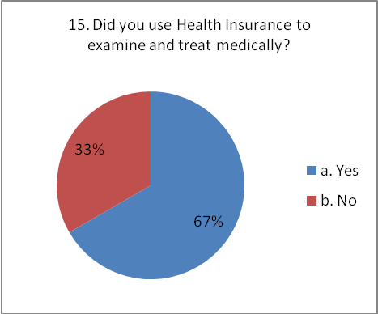
(Source: from M&E analysis system with the question No.11 )
Human resources to support IWCs are still limited. Although there are many needs of IWCs, they are just a small segment of living care. As most of Project Management Board Members (from governments) work part-time, there is time limitation in project participation.
Education level of IWCs is not high and some of IWCs do not actively participate in project interventions.
The education level of IWCs is low. Almost of IWCs did not finish secondary school. Their daily lives are so busy in earn living and as their low education, we do find it difficult to mobilize their participation. (Tong Van Thom- Syndicate Chairman in District 5)

PROJECT IMPACTS:
Improved living condition of IWCs and their family: During the past four years of implementation, the project has made some positive changes in the living condition of IWCs. It is clearly seen that IWCs’ awareness has been raised and risk factors related their work has been also reduced; their working condition has improved much while IWCs could easily access to services of health insurance and accident insurance. Furthermore, since IWCs has received much attention from community as well as project support, they are gradually happier and more open-minded; as their income has been increased, their living difficulties seemed to be reduced much as well.
- After having supports from project, we feel very happy. We know how to protect ourselves from occupational risks. People do not look down on us anymore as now we work under the management of cooperative which protects our rights and benefits. (Le Thi Yen Ly- Binh Thanh IWC)
- Community awareness is not the same as the past. In the past, they used to not let us get into their house and they used to spit at us also. Now, their awareness much improves.
- Now everything has changed. For example, if there is any member who got sick, other members of cooperative will announce to Management Board of Cooperative to support him/her, not like the past anymore when no one took care for others (Do Van Duoc- vice chairman of District no 6 Cooperative)
IWCs’ income has improved in comparison with past:
Chart 2: Monthly Incomes from waste collection fees of IWCs (Million VND)
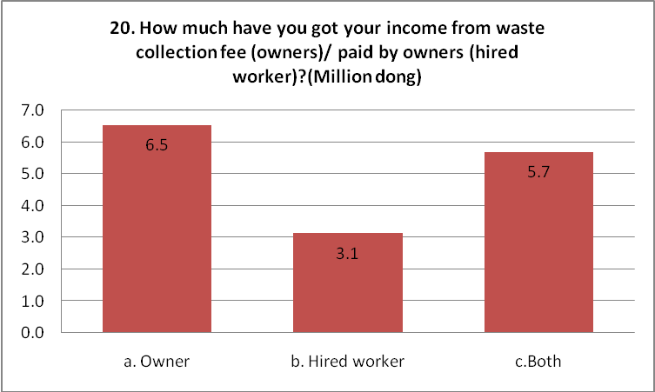

Chart 3: Monthly Income from selling recyclables (million VND)
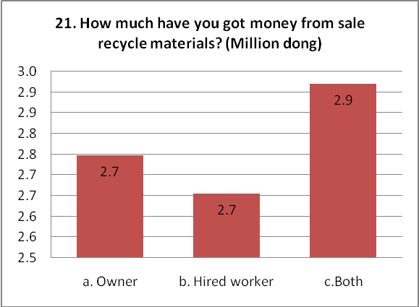

(Source: M&E analysis system with questions No.20 & 21)
According to Annual Report of 2011, the average income of IWCs was 3.2 million Vnd/month equivalents to 115 Euro/month (in which about 2.1mil from waste collection and 1.1 million from recyclables selling). However, their average income nowadays reaches 5.8 million Vnd/ month equivalent to 207 Euro/month (in which 3.1 mil from waste collection or monthly wave and 2.7 million from selling recyclables).
When asking them to share the changes in their life, IWCs mentioned many best cases. For instance, Mr. Tong Van Thom shared that they had used to loss their way without any concerns from community in past. Up to now, the project has been a link to connect IWCs and DONRE; television and mass media, community people get to know more about their works related to Solid Waste Management and they felt happier and proud of themselves that they has contributed much to the environmental protection and municipal sanitation. The exhilaration of IWCs when they talked about their samples of changing life showed that project brought great impacts on their lives and these changes have been recognized by IWCs.
IWCs have awareness how to take care their health and working condition. Thanks to process of interviewing and observation of 133 IWCs in total of 7 districts, the project recognized that IWCs have aware of occupational safety and diseases prevention, first aids more than before. Specifically, about 85-90% of IWCs wore their protective clothes during their work and they shared that this would be useful for their health.

Chart 4: Percentage of IWCs using protective clothes and masks when they collect waste

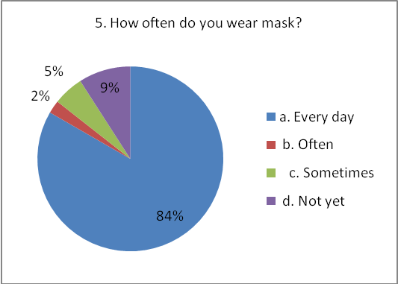
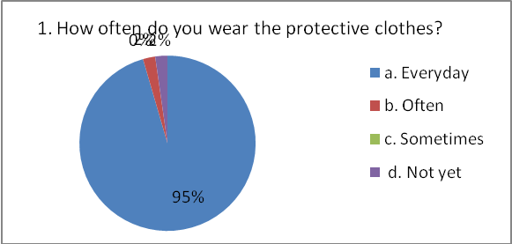
(Source: M&E analysis system with question No.1&5)
IWCs have aware of their health and pay more attention on it:
At first, when the project started to conduct health check-up, there were no IWCs taking part in. Now has been much different, IWCs often actively ask us when this activity will be taken place. We feel very happy as IWCs’ awareness has changed. They have not neglected of their health any more as before (Nguyen Quang Sang-Management Board of Binh Thanh Cooperative-FGD).
Community attitudes towards IWCs and their families have positively changed. Thanks to mass media and behavior change communication activities, community has understood much about IWCs’ life and job. In the past, people used to keep far away from IWCs or looked down on IWCs as they thought that waste collection was the indigent job. Now things has changed and community has known IWCs’ role in environmental protection and municipal solid waste management so they have empathy, understanding and create the better working conditions for IWCs.
People’s looks on IWCs has changed. In the past, they kept 3 meters far away from us with their muzzled noses. Moreover, they thought we were from the bottom of society. They even made us their toys. (Le Du Hoang – Cooperative Management Member of Binh Thanh district)
Currently, there have been 90% community people who don’t look down on IWCs thanks to communicative activities, mass media. The rest still do as they have their own stereotype on IWCs or as IWCs did not behave well with those households. The two sides are biased together. But there is not much anymore (Tong Van Thom- Syndicate Chairman of District 5)

Strengthened the voice of IWCs towards government and community: Besides direct supports and capacity building for IWCs, the project also has worked with DONRE to organize workshops in order to get ideas of IWCs on current regulations and policies related to themselves (such as Decision 88 and Decree 32 and Decision 5254 ...) and held photo- voice exhibition on Ho Chi Minh City Waste Recycling Day. Thanks to these activities, the voice of IWCs has been enhanced; community started to understand and have more sympathy to their job. It showed that community attitudes must also change. DONRE has also submitted their proposal to Ho Chi Minh PC on increasing collection fees in order to be more in line with current situation (so far, this proposal has not been approved yet as the HCMC People Council’s meeting has not taken place)

PROJECT MAINTENANCE:
Project results can be maintained thanks to these following reasons:
IWCs’ organizations operated properly under the management of the Cooperative or Syndicate (the IWCs’ organization of District 4 is managed by Ward PC so the quality of management seemed to be weaker than others); leaders of the cooperatives / syndicates, who have been capacity building, are always enthusiastic in the work of the cooperatives/ syndicates. This is also a great support for IWCs. In addition, each cooperative / syndicate is forming mutual self-help groups so they can get together to meet and share their own experience.
Project Management Boards have shown their good leadership role in supporting IWCs activities. This is reflected in the clear assignment of responsibilities and commitments in supporting IWCs from each member of the Management Board. Management Boards of all levels also showed a change in policy to mobilize community resources in order to support IWCs.
However, maintaining several models of the project will encounter some difficulties due to limited local budgets. In some interviews, members of the Management Board shared that models designed to support IWCs and their families were not difficult to be carried out and very well-suited but difficult to be maintained by local authorities due to limited budget.

VI. CONCLUSIONS
During the past four years of implementation, the project has obtained many achievements and scored these following set objectives:
- Improved working conditions, reduce risk factors on the health IWCs in HCM the city
- Improved access to health insurance and services for IWPARs at local level
- Strengthened IWPAR organizations’ business activities in integrated waste management systems.
Findings through project evaluation showed that the project has achieved 4 expected intermediate results as followings:
- Results 1: 6 Cooperatives/ Syndicates/ groups made their plan and were well-prepared for occupational risks to improve labor safety.
- Result 2: IWCs’ working conditions were improved (100% IWCs had trained on occupational safety; 100% IWCs were provided labors uniforms and equipments.
- Result 3: IWCs accessed to suitable social security and services through their organizations and project: 60% IWCs are checked-up every year; 50% IWCs accessed to health insurance.
- Result 4: 6 Cooperatives/ syndicates/ groups of IWCs could sign contracts to provide service / business in solid waste management system in order to increase and diversify their revenues and incomes.
After 4 years of implementation, the project has proven its successes in supporting IWCs to access social insurance. These successes were shown as following aspects:
- Conformity: Overall, the project support for IWCs and their families (vaccination, health check-up, protective clothes, health insurance, accident insurance, ...) has responded to the diversified needs of IWCs and capacity building activities for IWCs and management boards has raised and developed community capacity to support IWCs access to social protection and inclusion. This is also a prerequisite to ensure the maintenance of the project results. The appropriateness of these interventions has changed the life and working conditions of IWCs as well as improved their attitudes and life skills. The support of the project has contributed to healing the gap in term of their ability to access to health services, health care, accident insurance and, to increase IWCs’ income. The most convincing evidence for the conformity of the project was that HCM City Department of Natural Resources and Environment has made decision to use of local budgets (environmental fees) to partly support IWCs to buy health insurance.
- Management: Project management approach is very effective from organizing / strengthening cooperatives / syndicates; groups / mutual self-help groups, services to supporting IWCs (who were always received the community consultation or applied the community participation approach) to build partnerships, follow up, monitor and evaluate activities of the project. As the beneficiaries are IWCs, the project has organized meetings, observed and built databases to analyze information. When support is needed, the project has been continuously monitoring the use of supporting services as well as the positive improvement of IWCs. In addition, thanks to the close direction and coordination from management board and stakeholders as well as good relationship between Vietnam and Enda parties involved in the project, all project resources were increased and used effectively and efficiently. Furthermore, the community participation and community resources were mobilized at the highest level.
- Partnership. The project has built a close relationship, mutual understanding with the spirit of “all for development and better life for IWCs”. This relationship has brought more interactive way from the IWCs to all the Management Board of all levels and Enda Vietnam. This interaction ensures that the community has become more flexible, responsive and effective in responding to the diverse needs of IWCs.
- Community aspect: as mentioned in the previous sections, the project has built up the network of community partners who always accompany with IWCs such as network of students, network of NGOs, mass media. This enhances the positive social attitude towards IWCs, changes community behaviors and increases the self-confidence of IWCs which makes them no longer shy or shrinks.
- Human resource establishment and development: The project has organized many training courses and study tours for different stakeholders such as IWCs, Chairman of Cooperatives/ Syndicates, members of management board, and government official involved in the project. It can be said the content of these courses were really fruitful and various such as providing knowledge on Cooperative Law, Labor Union Law, Project Community based Management skills, Business Skills as well as organizing the study tour in Thailand…. However, these courses aimed not only to provide theoretical knowledge but also to enlarge practical skills for all stakeholders.

SUGGESTIONS
Thanks to findings from evaluation process, we would like to give some suggestions as followings:
Suggestion No 1: For Cooperatives/ Syndicates
This is a model of “Towards social inclusion and protection of informal waste collectors and recyclers” so that we would like to suggest these cooperatives/ syndicates maintain activities to motivate and encourage IWCs to actively participate in Cooperatives/ Syndicates. Syndicates should make plan to step by step form the cooperatives to ensure their members’ rights.
Communication in groups/ mutual self-help group should be maintained to increase capacity of IWCs and to form the network of IWCs in the city.
Cooperative should maximize the supports from Cooperative Alliance and related Departments, social organization to mobilize all resources and effectively support IWCs.
Suggestion No 2: For local authorities, especially Ho Chi Minh Department of Natural Resources and Environment (DONRE)
As DONRE is the management agency of IWCs in Ho Chi Minh City, we hope that DONRE will support to maintain activities such as using environmental fees to support IWCs with health insurance in order to help IWCs improve their living and working conditions.
Continue to review and adjust the current regulations/ decisions to help the IWCs improving their life and working conditions. Especially for waste collection vehicles should design how to fit the context in HCMC, no violation of the Decree # 32 and the IWCs have possible conditions to change the waste collection vehicles (previously, the proposal to switch the truck, however, there were some disadvantages because IWCs have not enough money to buy truck; It is not suitable for waste collection in the small alleys by truck; the cost for truck operation is very high and IWCs has many difficulties for testing trucks… For these reasons, IWCs still do not change the collection vehicles, they are continuing to use the homemade car three-wheel vehicles which is prohibited in Decree # 32 of the Government)
Suggestion No 3: For local IWCs
IWCs should actively participate in activities of Cooperatives and Syndicates in order to create the close link with the available networks. Besides, they should positively involve in Organizations of Independent Waste Collectors and Recyclers which help them to ensure their rights and benefits.
IWCs should change their own attitudes as well. They also have responsibility on environmental protection; contribute to improve waste collection vehicles to ensure the environmental sanitation so that all levels of local authorities could make decision to adjust current regulations/ decisions. In case that, they still keep using their handmade waste collection vehicles which caused to environmental pollution due to water dripped from the broken trucks, or from many bags hanging in the trucks. This makes the advocacy process to change current policies/ regulations on collection vehicles more difficult.
They also need to maintain their communication activities through community to raise people’s awareness.
- ANNEX:
Focus Group Discussion Questionnaire
INFORMATION COLLECTION AND PROJECT EVALUATION
NOTES: the following questions are main contents for group discussion. Depending on the characteristics of each group (Groups of Cooperatives/ Syndicates Management Board or Groups of IWCs) that the facilitators adjust accordingly to ensure that there is sufficient information.
Duration: from 90 minutes to 120 minutes
Topic | Main questions
- Incomes | - How many households do you collect waste from? Are your employer or employee?  - How many recyclables do you collect every day? How many kg for each kind of these recyclables? How much does it cost?  - How much is your incomes from waste collection? How much is your income from recyclables selling?
- Expenditure | - What is your main income of your family?  - How much do you expend for yourself/ your family per day/ month? What is your average expenditure?  - Does your expenditure come from collection incomes or other incomes?  - Who makes decision on expenditure in your family?
Training& education | - Do you participate in any vocational training / skill course?  - For Management Board, have you ever participated in short/ long-term training course? If yes, have you own any certifications?  - How old are your children? Do your children work or go to school?
- Working conditions | - How long does it cost from your house to working place? How long do you spend on waste collection? How long does waste transportation to transfer station take? When do you take a rest?  - How many people do you work with? What do they do to assist you? Have you ever gone into quarrel with them? How did they treat you?  - Have you ever felt uncomfortable/ tired of noises/ bad odors?  - How many households in your routine practice waste sorting at source? How many households haven’t practiced waste sorting at source?  - Are there any rest room/ clean water/ shampoo in your work place?  - For female waste collectors: is there any disadvantage do you have to face up with during your work? Do you work when you are pregnant? If not, how do you deal with? How can you deal with your work when your children are so young?
- Health | - Who takes care of your children when your children are sick?  - Who takes care of you when you are sick?  - Who pays for all costs of sickness?  - For female IWCs: Have you done regular check-up when you are pregnant? Where did you give a birth?  - Have you ever been in the situation of not having enough money to pay for hospital fees/ medicines/ operation? How have you faced up with that situation?
- Project Evaluation | - In your opinion, How do training courses (Occupational Safety, First Aid, Diseases Prevention and control, Gender Equality, Communication skill) conducted by project affect to your working and life?  - How do direct supports such as providing labor clothes and equipments affect you?  - How do project supports such as vaccination, health check-up, health insurance, accident insurance affect you?  - What do you think about photo-voice activity; meetings to get opinions from IWCs/ local authorities on current regulations/ policies?  - How is your life and working condition changes with support from IWPARs project?
- Suggestion | - Do you have any suggestion for project?

QUESTIONAIRE TO INTERVIEW MANAGEMENT BOARD OF COOPERATIVES/ SYNDICATES

- Would you please introduce yourself and your family?
- When did you participate in Cooperative/ Syndicate? How many hours do you spend in activities of Cooperative/ Syndicate?
- How do you recognize the changes in life of your cooperative/ syndicate members compared to the time before Enda Vietnam implemented the project? What did your cooperative/ syndicates contribute to these changes?
- Do you think that community attitude towards IWCs has changed? If yes, what are these changes in details?
- What are activities of your cooperative/ syndicate? Please list in details. What are benefits that these activities bring to cooperative/ syndicate members?
- Have you ever participated in training courses which were designed for cooperative/ syndicates members? How did this activity affect to your job? Besides, which support did you received? Which support do you need in order to better your work?
- Who or which agency did you contact with? For what problem? Who managed and supported you in activity implementation? Where do your meetings of Cooperative take place? Are these places convenient or not?
- In your opinion, which is the most effective support among training courses on capacity building, health check-up, vaccination, buying health insurance, accident insurance, providing labor clothes/ equipment? Why? Which is the least effective support? Why?
- What do you need in order to better your cooperative? Are activities of your cooperative/ syndicates appropriate? If not, why?
- Which factors contribute to the success of your cooperative/ syndicate in specifics and of project in general? Please list in detail. Which factors brought the negative effect to the operation of your cooperative/ syndicates in specifics and of project in general?
Thank you so much

QUESTIONNAIRE FOR THE RANDOM CHECK

District…………......Name………………  A. Protective devices:  1. How often do you wear the protective clothes?  a. Everyday b. Often c. Sometimes d. Not yet  2. According to you, why it is important to wear the protective clothes?  a. To be protected b. To follow the rules  c. It’s not important  3. How often do you wear gloves?  a. Everyday b. Often c. Sometimes d. Not yet  4. How often do you wear boots/shoes?  a. Everyday b. Often c. Sometimes d. Not yet  5. How often do you wear mask?  a. Everyday b. Often c. Sometimes d. Not yet  6. If you did not wear gloves/boots/mask every day, why?  a. Inconvenient b. Useless c. Uncomfortable  B. Tetanus vaccination:  7. How many times have you been vaccinated for the tetanus?  a. One b. Two c. Three d. Not already  8. If not three, why?  a. Waiting for the 2nd or 3rd injection  b. Get fever and pain after vaccinated one time before.  c. Know information but do not have time to join  d. Know information but afraid of shooting  e. Do not have information about time and venue.  C. Social security and healthcare:  9. Are you adherent to a Social insurance?  a. Yes b. No  10. If No, why?  a. Too expensive b. Complicate to access  c. Cannot buy it d. Unnecessary.  11. Are you adherent to a healthcare insurance?  a. Yes b. No  12. If No, why?  a. Too expensive b. Complicate to access  c. Cannot buy it d. Unnecessary  13. Have you get any health problems in recent time?  a. Yes b. No  If Yes, what are they? ......................................................................................  14. According to you, is it serious or not?  a. Yes b. No  (If Yes, continue to Question 15) | Age…………………Sex:…………….  15. Did you use Health Insurance to examine and treat medically?  a. Yes b. No  If No, Why? .....................................................................  D. Good practices on OSH and First Aids  16. Have you ever participated in Training/ group discussion about OSH and First Aids?  a. Yes b. No  17. In your opinions, what is the main risky in your jobs?  …………………………………………………………………………………………..  18. While you are working, do you have any solutions to protect yourself from that risk?  a. Yes b. No  What are they?  ………………………………………………………………………………………………………………………………  E. Income generation  19. Are you an owner of the route collection or a hired worker for another owner?  a. Owner b. Hired worker c. Both  20. How much have you got your income from waste collection fee (owners)/ paid by owners (hired worker)? Is it higher or lower than its last years? Why?  ………………………………………………………………………………………………………………………………  ...............................................................................................  21. How much have you got money from sale recycle materials? Is it higher or lower than its last year? Why?.......................................................................................................................................................................................  ………………………………………………………………  Quantitative question  According to you, What is the impacts of the project?  ………………………………………………………………………………………………………………………………………………………………………………………………………………………………………………………………………………………  Interviewer:

